QuickRDA Modeling System

Domain Fact Entry Form User Guide

Erik Eidt

Version 3.2

August, 2011

***Copyright (c) 2011, 2012 Hewlett-Packard Development Company, L.P.***

The Standard Entry Form 6

Columns In General 7

Normally Hidden Rows 7

The Metadata Rows 8

Column Declarations for Relationships 10

Column-Specified Relationships 10

Cell-Specified Relationships 10

Cell Values as Titles of Concepts 11

Kinds of Tabs 12

Full Tabs 12

Focus Tabs 12

Source Unit Organization 13

Choosing Full Tabs or Focus Tabs 13

Use of Tabs 13

Use of Rows 13

Getting diagrams of Interest 13

The Standard Template Tabs and Columns 15

Columns of the Full Tabs 15

Dropdowns — the RDA Set Dropdowns Button 18

Repairing dropdowns 18

Breaking Links 18

Hidden Columns or Rows 19

Worksheets & Tables 20

Excel Tables within Worksheets 20

Raw Worksheets 20

CSV Files 20

Differentiators 22

Graph Customization 23

Coloring 23

Styles 23

Troubleshooting 24

Excel Security Warning: Automatic Update of links has been disabled (Enable Content) 24

Some Facts are Not Appearing in the Diagram 25

the table has been Altered 25

Blank Column Header in Table 25

Wrong Coloring or Values for Metadata Rows 25

Facts Outside of Table 25

Error message from QuickRDA in execution of the dropdowns button 25

References 27

QuickRDA: Modeling System Diagram Generation Guide 27

QuickRDA: Modeling System Metamodel and Template Developer Guide 27

***Table of Tables***

Table 1. Columns of Tabs for RDA Business Contextual Architecture 16

***Table of Figures***

Figure 1. A Tab with other Metadata Rows Hidden 7

Figure 2. A Tab showing Metadata 8

Figure 3. Excel says There's a Problem with Links 24

Figure 4. Column Reference Not Found Error from QuickRDA 26

# The Standard Entry Form

RDA domain models are captured in QuickRDA Modeling System, which is based on Microsoft Excel. Almost all of the normal features of Excel are available, such as copy & paste, formatting of rows & columns, multiple worksheets, multiple workbooks. The tables are row-order independent, so even Excel Data filtering works, as does Excel Data sorting with some caveats. The worksheets are data only, that is, there are no Excel formulas used in source units, which makes the capture simple and ultimately more accessible.

The QuickRDA tool comes with a standard template for RDA, which is a macro-free Excel workbook with a number of tabs. At present, this template includes tabs for capture of Business Contextual Architecture and Conceptual Service Architecture. Domain model concepts and relationships are captured by populating cells in these tabs, which is a source unit. This paper’s focus is within a single source unit tab.

RDA domain models are graphs of elements, that is, nodes and edges, wherein the nodes represent concepts and edges represent relationships. Both concepts and relationships are identified by name.

The purpose of cell entries is to declare a concept, or a relationship between two concepts, and often both. Sometimes we refer to a declared concept or relationship as a fact. Each fact in the tab across all the columns and rows is accumulated to the whole and made available for used in the build mechanism for diagram or report generation.

* Concepts are created by an entry in a cell of a column that is structured to declare concepts, and, relationships are created by entries in at least two cells of different columns *of the same row*.
* There are two ways for declaring relationships: *column specified* (fixed per column, i.e. the same for all rows) and *cell specified* (variable for each row).
* Declaration of facts are idempotent — the first mention (of the name used to declare a concept) seen by the tool is taken as a declaration and subsequent mentions of that name become references to the same concept, which are often needed in the construction of relationships. *(Given that idempotent nature of concept mentions, it isn’t significant which specific mention is first. Note that relationship declarations are equally idempotent.)*
* Blanks are often used; a blank cell simply doesn’t enter the concept or relationship(s) specified by the column declaration(s).

The standard template also comes with a build tab, which is used to combine source units to build diagrams or reports; the description of the build tab is in the document QuickRDA: Modeling System Diagram Generation Guide.

Along with discussion of the tabs and columns in the template, this document also provides discussion a number of other considerations. First, there is a glimpse into the underlying column mechanism.

# Columns In General

This section gives an overview of the fairly general purpose mechanism behind columns for declaring and capturing RDA facts..

## Normally Hidden Rows

Each column declares the meaning of data in its cells through general purpose metadata declaration, which includes the column header. Often we’ll hide the two additional metadata rows (plus one blank row), here row 2-4 are hidden:

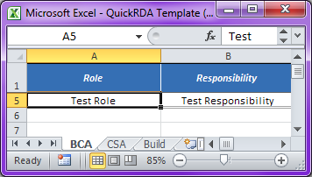

Figure 1. A Tab with other Metadata Rows Hidden

*One blank row, 4, is also typically hidden so that inserting a new row at the top doesn’t copy the formatting from the above row. When these metadata rows remain hidden, Excel’s Data sorting feature works, however, when these rows special to RDA are unhidden, using Excel’s Data sorting is not a good idea.*

## The Metadata Rows

The columns have three rows of metadata, the first of which is a column name header, and is followed by two additional rows of metadata (which are in pink).

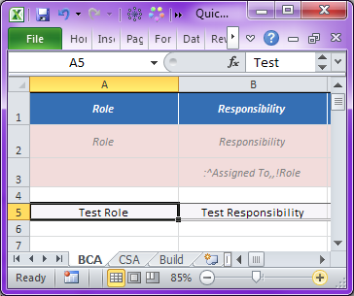

Figure 2. A Tab showing Metadata

The metadata rows are:

1. The header shown here is in row 1, which provides the column name. The name of the column must be unique in the table, and, the column names are being referenced from the other metadata in this same table (so don’t change them arbitrarily).
   * Other than being referenced from within the same table, the header names are not significant — they don’t add to the accumulation of facts for diagramming or reporting; they are private to the table they are in.
   * The column headers make the columns order independent *(but with the standard template tables, the ordering is chosen so that reading relationships makes the most sense: subject columns are organized before relationships columns, which are before object columns so facts that use cell-specified relationships can be read as subject, relationship, object (by skipping blank cells when reading a row))*.
2. The next row of metadata, here in row 2, is the column type, which designates a concept name from an RDA layer, such as Role from the contextual layer.
3. The last row of metadata combines two things: an indicator of whether this column should enter a concept declaration, and, any relationships that should be taken from this column with cells from other columns in the same row. The relationships are described using a string that identifies a simple sentence, namely a subject, a relationship, and an object. Subjects and objects are usually references to other cells in the same row by naming the column header *(this is the above-mentioned usage of the names in the column headers)*.
   * When this metadata cell for some column is blank or empty, then this indicates that the column declares only concepts not relationships; this is the case with the Role column A shown here.
   * When this metadata cell has text, as is the case with column B shown here, this indicates that the column will declare one or more relationships.

Entries in the column A in rows 4 and greater will declare or reference a Role whose title is take from the value of the entry in the cell, for example, as seen in Row 5, “Test Role” becomes a declared Role.

The columns in the standard template are pre-structured for specific purposes; the standard columns are explained in a later section.

This document gives a brief glimpse into the column structure that is helpful in understanding how the columns related by looking a bit under the hood. Complete metadata description as an extensibility mechanism and described in detail in QuickRDA: Modeling System Metamodel and Template Developer Guide.

## Column Declarations for Relationships

As introduced above, relationships are expressed using one of two approaches: column-specified (fixed or constant) relationships or cell-specified (variable) relationships. (The approaches can be mixed.)

### Column-Specified Relationships

Column-specified relationships always use the same relationship for each applicable row. Creating column-specified relationships requires a minimum of two columns, one for each concept that will be linked by relationship that is identified in the column definition. These columns declare concepts, and, at least one of the columns will also declare a column-specific relationship, resulting in a relationship fact captured almost as a side effect of expressing two concepts in the columns of the same row.

This approach is used by the Responsibility column, above, column B. The cells of column B, when not blank, declare the titles of responsibilities. However, an additional piece of metadata in the column definition says that when column A and column B of the same row are have entries (are non-blank), then an additional fact is generated linking the two concepts: the Role entered in column A is linked to the Responsibility entered in column B, via the Assigned To relationship.

Note that any column can declare one or more column-specified relationship. For example, equally plausible would have been if column A defined that the Assigned To relationship between itself and column B instead of vice versa. *(Both columns, in fact, could have specified Assigned To between each other as a column-specified relationship, though one of these specifications would be redundant though harmless due to the idempotent nature of facts.)*

### Cell-Specified Relationships

Cell-specified relationships can declare a different relationship for each row. Using cell-specified relationships requires at a minimum of three columns, because the relationship itself will be specified a column. Such relationship columns will have a column type that is an abstract property, which is an expression of the form “type1->type2”, whose meaning is: any named relationship that relates concepts of the type1 kind to concepts of the type2 kind.

The modeling system provides dropdowns for these columns to aid usage, since only appropriate relationships as defined in the Domain Model Definition are proper. The tooling does not preclude manual entry of inappropriate relationships; though they will be tagged with a data validation error in the spreadsheet, and appear in the graphed diagrams in red, which are indication of the error.

# Cell Values as Titles of Concepts

When capturing a concept in a QuickRDA worksheet, the text entered into a cell becomes the title of that concept. The title will appear in diagram and reports. The title is also is used to refer to that concept from other rows or columns, as is often done to express relationships involving that concept.

This name being a title, the recommend style is capitalizing significant words, as would be done with a document title.

The title is used to match concepts not only within a single table, and not only across worksheets of a single workbook, but across workbooks. Since a large project will have many concepts across a number of workbooks, the title should be a descriptive phrase rather than a single word.

The QuickRDA modeling system does case-insensitive matching of title names to determine if two titles is the same concept. However, it is recommended to use the consistent case for the same concept for consistent results.

*(The modeling system will take as the title declaration the first one it sees, which has to do both with build order of the tabs and the way the modeling system scans a single table. Use of mixed case to refer to a concept can result in output (e.g. diagram) changes as the source units — or even modeling system itself — are versioned.*

*For example, older versions of the modeling system used a column-major traversal order, and newer versions use a row-major traversal order; thus, the first mention of the same concept may be a different cell. Further, there is no promised order to the processing of columns (whether the traversal is column-major or row-major) because of the nature of how columns reference each other to build facts.)*

# Kinds of Tabs

For each of the architectural layers, there are two kinds of tabs: full tabs and focus tabs.

## Full Tabs

Full tabs contain all of the columns needed for expressing the concepts of a layer — and thus are rather wide. When using a full tab, we can expect cells of rows to be sparsely populated — there will be lots of blank cells.

*(While sufficient columns exist in the standard full tabs to express all concepts of a layer, they are still a chosen subset of all the possible columns that could be constructed (using metadata descriptions) for addressing capture of a layer; this is just to say that the columns of the full tabs.)*

## Focus Tabs

Focus tabs target specific subsets of information that one might capture within a layer; several different focus tabs can be used to capture a layer. The focus tabs show fewer columns, and would be more densely populated, and will have an appearance more like normalized data than full tabs do.

The focus tabs in the standard templates also actually *have all of the columns* — though the columns that don’t address this subset of this focus are hidden. These hidden columns can be deleted, but there is little reason to do so. Leaving them allows copy and paste of whole rows between the various tabs of the same layer. Note that if information is in hidden cells, it won’t appear in the diagram.

Of course, it is also possible to mix population styles: some columns can be used for dense population with a few other available columns to add information sparsely.

# Source Unit Organization

How to use source units depends on several factors, generally speaking the number of concerns involved. The more authors doing simultaneous modeling, the more individual workbooks would be expected, in support of independent authoring. The broader the scope of the capture, the use of more of the varied worksheets would be expected.

As previously noted, declarations of facts are idempotent, and, duplication is sometimes necessary in capturing relationships. The modeling system will simply accumulate facts, and, duplication is not taken an error.

Developers should take care to avoid unnecessary duplication for the usual reasons associated with DRY (Don’t Repeat Yourself). Each fact — especially relationship facts (as they are more complex than concept facts) — should be considered as having a home location, and replication of the fact at other locations (rows within the same source unit or across multiple source units) should be limited to that needed as reference (for declaring (new) relationships).

## Choosing Full Tabs or Focus Tabs

The full tabs mostly included for reference; they are confusing for a number of reasons. They are very wide, which decreases ease of use and capture, as it often requiring scrolling. Further, since there are so many choices available, it doesn’t instruct on proper layering of capture.

Focus tabs are geared toward the layering of capture, specifically on contextual layer, at present.

## Use of Tabs

Tabs of the spreadsheet can be cloned. Columns can be hidden. I find it particularly helpful to have tabs concentrate on particular subset of concerns. When doing this certain columns will always be blank, and can therefore be hidden (or deleted, however, hiding is less destructive, more reversible). Thus, we can get to tabs that have more specific purposes using fewer, more densely populated columns.

## Use of Rows

It is certainly possible to place many facts in one row, especially when using tabs that have many columns. However, it can often be confusing to do so, and until the practitioner is familiar with what is being captured, we advocate the use of more rows of simpler facts over fewer row more densely populated with facts.

## Getting diagrams of Interest

Prior to the presence of Advanced Diagram Filtering in the QuickRDA modeling system, the only smallest diagram that could be generated was that of a single source unit. Thus, to limit the detail of a diagram involved organization of declarations across additional source units. Graphing a single source unit was and is a quick way to limit diagram complexity. These smaller source units could then be combined to show larger diagrams.

Though the technique of using multiple source tabs to organize declarations is still useful, it leaves lots to be desired. For one, it is not always clear when a new area is being captured that might merit a new diagram —and thus necessitate a new source unit.

With the introduction of Advanced Filtering Expressions, a single source unit can be filtered to provide a diagrams that each focus on specific interest(s). Also, source units can be combined, then so filtered, so that a diagram of specific interests can be generated from combinations of sources, meaning that all concerns can be more distributed across source units.

This means that source unit organization, which still useful, is no longer as constraining to diagramming as it was before.

# The Standard Template Tabs and Columns

## Columns of the Full Tabs

The following table shows columns of the “BCA-full” tab, which is for the RDA Business Contextual Architecture layer.

|  |  |  |  |  |  |  |  |
| --- | --- | --- | --- | --- | --- | --- | --- |
| ***Column Letter*** | ***Column Header*** | ***Kind of Column*** | ***Concept Type*** | ***Relation-ship Kinds*** | ***Relationship Name*** | ***Subject Column***  ***Header***  ***Name*** | ***Object Column***  ***Header***  ***Name*** |
| A | Role | Concept | Role | - | - | - | - |
| B | Responsibility | Concept + Fixed Rel. | Responsibility | Fixed | Assigned To | *this column:*  Responsibility (B) | Role (A) |
| C | Provides| Consumes | Variable Relationship | - | Variable | *From this Column* | Responsibility (B) | Artifact (D) |
| D | Artifact | Concept | Artifact | - | - | - | - |
| E | Provided By| Consumed By | Variable Relationship | - | Variable | *From this Column* | Artifact (D) | 1. Resp 2 (H) 2. Role 2 (J) |
| F | Responsibility to Resp 2 | Variable Relationship | - | Variable | *From this Column* | Responsibility | Resp 2 |
| G | Role to Resp 2 | Variable Relationship | - | Variable | *From this Column* | Role | Resp 2 |
| H | Resp 2 | Concept + Fixed Rel. | Responsibility | Fixed | Assigned To | *this column:*  Resp 2 | Role 2 |
| I | Role to Role 2 | Variable Relationship | - | Variable | *From this Column* | Role | Role 2 |
| J | Role 2 | Concept | Role | - | - | - | - |
| K | Artifact to Artifact 2 | Variable Relationship | - | Variable | *From this Column* | Artifact | Artifact 2 |
| L | Artifact 2 | Concept | Artifact | - | - | - | - |
| M | Actors | Concept | Actor | - | - | - | - |
| N | Actor Classes | Concept | Actor Class | - | - | - | - |
| O | In Plan | Variable Relationship | - | Variable | *From this Column* | Role to Role 2 | Plan |
| P | Plan | Concept | Plan | - | - | - | - |
| Q | P|C Refinement to Operation | Concept + Fixed Rel. | Operation | Fixed | Refined By | Provides| Consumes (C) | *this column* (Q) |
| R | Responsibility Refinement to Service | Concept + Fixed Rel. | Service | Fixed | Refined By | Responsibility (B) | *this column* (R) |
| S | Role Refinement to Tower | Concept + Fixed Rel. | Tower | Fixed | Refined By | Role (A) | *this column* (S) |
| T | Artifact Refinement to Document | Concept + Fixed Rel. | Document | Fixed | Refined By | Artifact (D) | *this column* (T) |
| U | Description | Special | String | - | - | - | - |
| V | URL | Special | String | - | - | - | - |
| W | Color | Special | String or Number | - | - | - | - |
| X | Style | Special | String | - | - | - | - |
| Y | Notes | - | String | - | - | - | - |

Table 1. Columns of Tabs for RDA Business Contextual Architecture

The focus tabs of the Business Context Layer are:

* Example Actors — uses columns A and J to capture roles Example Of relations to other roles.
* Abstract Domain Parties — uses columns A, I, J, O, and P to capture roles, relations to other roles, and plans that form the networks within which they interoperate.
* Composite Roles — uses columns A, I, J, O, and P to capture roles, relations to other roles, and plans that form the networks within which they interoperate
* Roles In Opposition — uses columns A-J to capture
  + A-D for capture of roles, responsibilities, artifacts,
  + E & F are optional for capturing opposing responsibilities regarding the same artifact on the same line
  + F & H capture responsibility composition/decomposition
  + G & H capture role to responsibility relations as in RACI
  + I & J capture role composition/decomposition
* Artifacts
  + D, K & L capture artifacts and artifact composition/decomposition

The focus tabs all correspond to one of the capture concerns described in the Modeling Guide. The first four focus tabs correspond to the section Framework for Layering Roles in that guide, and the last corresponds to the artifacts section in that guide.

# Dropdowns — the RDA Set Dropdowns Button

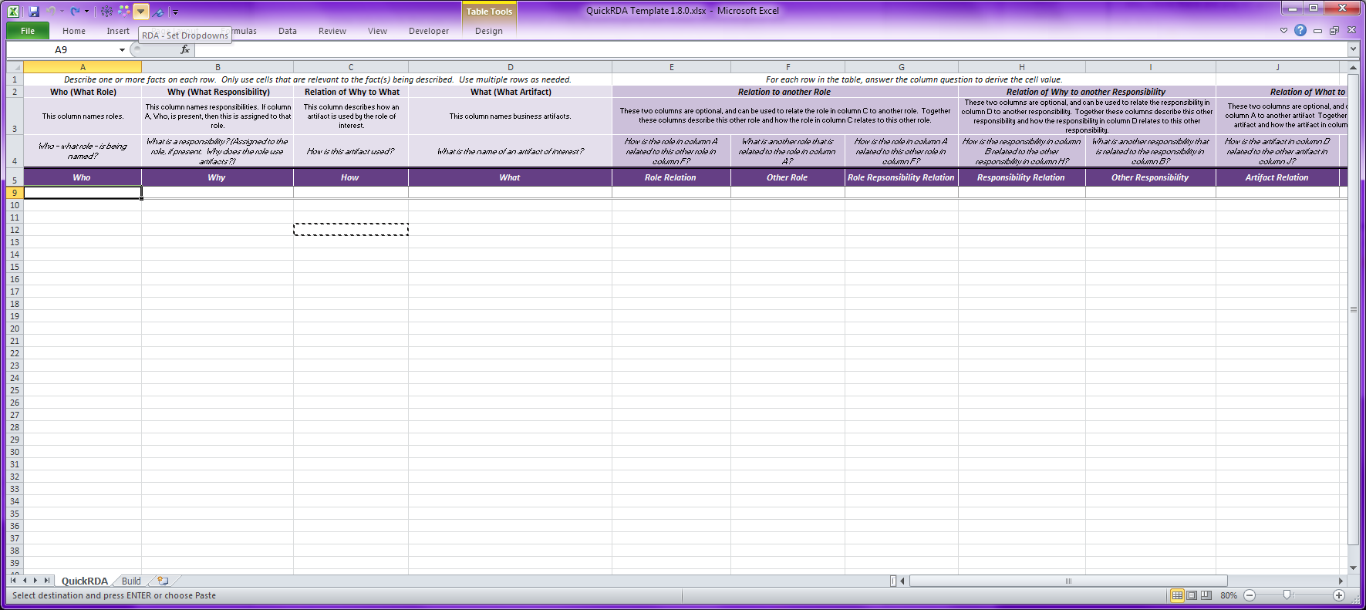

This button will generate dropdowns for certain columns; it is used to generate dropdowns when inserting new columns, such as modification or creation of a new template.

## Repairing dropdowns

In Excel, simple copy & paste operations can accidentally destroy Excel Data validations that provide the dropdowns (not to mention formatting). The dropdown button can also be used to repair dropdowns after they’ve been damaged this way.

Copying a tab between two worksheets will also require repair of the dropdowns.

## Breaking Links

This button will also repair broken links. See Excel Security Warning: Automatic Update of links has been disabled (Enable Content).

*Note that for Excel 2010 the RDA dropdown button fix the underlying problem and this banner warning will immediately disappear, but, for Excel 2007, even though the underlying problem is fixed, the banner message will persist until the workbook is (saved and) reloaded.*

# Hidden Columns or Rows

If information is in hidden cells, it won’t appear in the diagram. Specifically,

* Columns can be hidden
* Rows can be hidden

Hiding of rows can also be used as a simple way to focus content of a diagram. What one could do is create an additional column as a category, and then, use Excel’s data filtering to exclude/include categories of interest. Multiple such columns could be used. Any row hidden by data filtering will not be included in the accumulation used for diagramming. However, the modeler should also consider using advanced filtering expressions as these are intended to replace simple category-based filtering.

# Worksheets & Tables

Excel has several ways of describing tabular data. On is with a raw worksheet, the other is with what are called Excel Tables, which are sub portions of worksheets.

The modeling system accepts source unit tabs that are setup as Excel tables within worksheets, or as whole worksheets without Excel tables. There is a slight trade off in the use of these. At present, Excel tables are the recommended form, since the error indicators are better.

## Excel Tables within Worksheets

Excel Tables support the dropdowns with error indications much better, but sometimes cause Excel to disallow what ought to be ordinary copy & paste and insertion operations. Forgoing the use of merged cells everywhere on the worksheet mitigates most of these issues for the most part (so we’ve updated the tabs that way).

*When using Excel tables, one has to be sure that the data being entered is actually in the Excel Table and not just on the worksheet (especially below the table) because rows below the table are not considered by the tool. For this reason, the supplied template tabs using Excel tables are formatted so as to provide a double line at the end of the Excel Table, an extra visualization of where the table ends. Excel automatically expands the table, so for the most part this works pretty well, but sometimes manual intervention is required to force the table to expand. Entering data in the row immediately below the table causes it to expand, as does most copy & paste immediately below the table. Entering data into cells that are more than one row below the current end of the table will not be interpreted by Excel so as to expand the table, leaving data entered there out of the table. One way, among several others, that you can manually enlarge the table, when necessary, is by dragging the widget that appears the rightmost, bottom cell of the table to encompass the desired additional rows.*

FYI, you can tell if something that looks like a table is an Excel table or not by selecting any cell it contains — preferably a cell in the header row. If this selection suddenly makes the Table Tools/Design menu appear, then it is an Excel Table.

## Raw Worksheets

Raw Excel worksheets are supported, but must start in cell A1 of the workbook. Otherwise, they work much like Excel Tables without the headaches. The only drawback is that error tags do not automatically appear when a relationship is used that isn’t recognized (an error), and the performance of data validation circles (the manual way to see validation errors) is abysmal.

## CSV Files

CSV Files are supported. Of course, only one tab per file is allowed using CSV’s. The QuickRDA tool must recognize a table as an RDA table. This is done (ahem, cough) using coloring for the Excel-based worksheets. For CSV, since coloring is not available, the first cell, A1, should have the text “QuickRDA”, and the table then starts (with header row) in A2.

A build table can also be in a CSV, this is done by putting the text “QuickRDA Build Table” in A1 of the CSV; the build table starts (with header row) in A2.

# Differentiators

Sometimes, it is desirable to duplicate or repeat the same artifact or responsibility or role — this can improve the quality of the capture and the diagram. For example, if we’d like to describe a middleman situation, say, in which Henry has a responsibility that provides a book to Elizabeth, and she has one that provides one to George. Without differentiation, the capture will indicate that the interactions are over the same artifact type, which is true. However, additional clarity can be achieved through use of a differentiator to separate the interaction between Henry and Elizabeth, and Elizabeth and George.

For the tooling, a differentiator is described within double angle brackets. Current convention is to create a differentiator that is a name: value pair (without spaces). For example, if the regular name of the concept is “book”, then a differentiated version is “book <<from:Henry>>” and another is “book <<from:Elizabeth>>”. With these two artifacts, we can now separate the interactions — between Henry and Elizabeth, we exchange the former artifact, and between Elizabeth and George, we exchange the latter artifact.

This example doesn’t require *two* differentiators: we just used two to make it fair, since neither usage had any reason for preference to the undifferentiated artifact. When a differentiator is used, the undifferentiated concept probably remains best used for describing more general relationship. A differentiated name and undifferentiated name refer to the same concept when the undifferentiated name part is the same; there is no need to capture a relationship between the various differentiations of the same concept or the undifferentiated version of the same concept, or to replicate across them with relationships to other concepts.

*(Occasionally, we may use a differentiator to describe a generic responsibility being applied in more than one context; however, it is probably better practice to name the responsibility differently; work on generic roles and generic responsibilities, is ongoing and may serve as an alternative.)*

# Graph Customization

Custom coloring and style features are accessible, more or less as an experiment, at present.

## Coloring

Elements on the same row can be given a custom color using the color column. The color can be specified in hex (RGB), such as 0x77FF77. The color can be specified in decimal, having the same interpretation of RGB.

## Styles

Styles can be used to name colors and shapes.

* To create a style, create a concept such as artifact
  + with a particular RBG Color, or when using excel you can set the fill color.
  + All shapes are passed through to GraphViz as node shapes, hence they are poorly defined here.
    - The list of supported shapes may change in the future.
* To use a style, designate this concept in the Style column.

To create separate styles without diagramming them, put them on a separate tab in the spreadsheet dedicated to the styles. Then include the styles using the invisible include feature of the build table for diagrams. Note: don’t include the styles tab when generating a report.

# Troubleshooting

## Excel Security Warning: Automatic Update of links has been disabled (Enable Content)

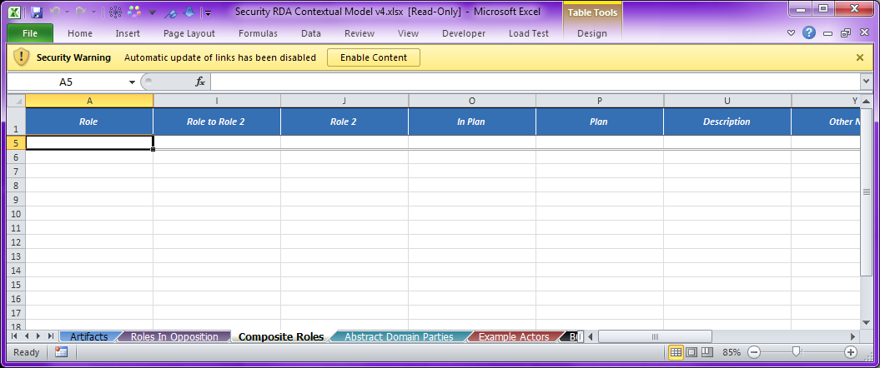

Figure 3. Excel says There's a Problem with Links

These problems are usually caused by either copy & paste of cells from one workbook to another, or by copy or moving a tab from one workbook to another. Sadly, often this error will only appear for other users, such as when it is emailed or otherwise to someone else. This is because on the original user’s machine, the links it needs are present in some other Excel workbook; when separating the workbook from that machine, the links are now broken.

But there’s a simple fix: use the QuickRDA dropdowns button — that’s it! You can do this if you get this message in a workbook, or, inform the author and have them do it.

For more information on the QuickRDA button, see Dropdowns — the RDA Set Dropdowns Button.

*Note that for Excel 2010 the RDA dropdown button fix the underlying problem and this banner warning will immediately disappear, but, for Excel 2007, even though the underlying problem is fixed, the banner message will persist until the workbook is (saved and) reloaded.*

## Some Facts are Not Appearing in the Diagram

There are several possible causes of this.

### the table has been Altered

#### Blank Column Header in Table

To work properly, all columns of the table must have non-blank, unique column names. If have a column name is that is blank — as sometimes happens on insertion of a new column — all columns after that are effectively not seen by the tool.

#### Wrong Coloring or Values for Metadata Rows

The metadata rows are important for the internal operation of the tool. (They are more fully described in QuickRDA: Modeling System Metamodel and Template Developer Guide.)

For the purposes of troubleshooting, well describe that QuickRDA source units are tables (raw worksheet or Excel tables) that have 3 special rows at the top. The first is simply the column header, but the names here are important, which we’ll explain in a second. The second is the column type specification, a metadata row, and the third is the relationships metadata row. Both the metadata rows must have the characteristic pink color in order for the tool to recognize the table as a QuickRDA table.

### Facts Outside of Table

QuickRDA accepts two kinds of tables as source units. One is the simple worksheet and the other is an Excel Table. Referring to Figure 3 above, we can see that this form is an Excel table, because when a cell in the table is selected, Excel displays the Table Tools menu. If facts are added to the columns but below the double line then they won’t appear in diagrams as they aren’t entered as facts. See the following section for more information Excel Tables within Worksheets.

### Error message from QuickRDA in execution of the dropdowns button

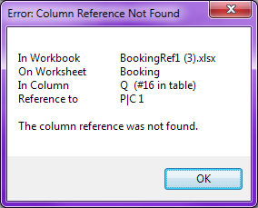

Figure 4. Column Reference Not Found Error from QuickRDA

This error message means that

# References

##### QuickRDA: Modeling System Diagram Generation Guide

##### QuickRDA: Modeling System Metamodel and Template Developer Guide